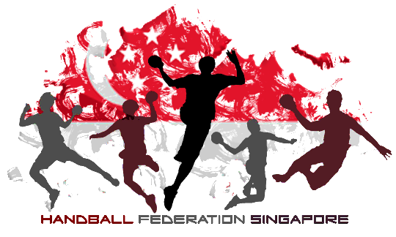
93 Hougang Ave 4, #01-02,
Singapore 538832

Cancellation of Beach Handball National Team Trials
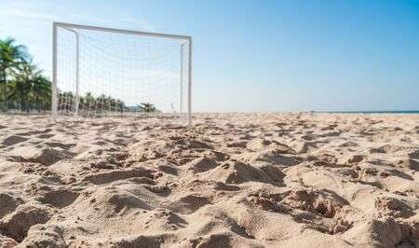
Adhering to the latest restriction to curb and prevent further spread of the Covid 19 situation, it is with regret that the Handball Federation of Singapore will cancel the upcoming trials meant to be held on 4th and 11th April 2020.

Players that have notified and registered their interest of participation towards the trials will be contacted separately, where they will be accessed basis their past handball/beach handball performance should there be any upcoming competition squad to be formed.

We hope to continue with further trials to continue our talent scouting once the health risk restriction is alleviated. Should there be any queries or concerns, please feel free to get in touch with any committee members of HFS.
Regards,
Hong Zhen You
President
Handball Federation of Singapore

